Mini-Retreat Updates
Two Thursdays ago, Working Group and Steering Committee members met to discuss and come to consensus on areas of importance.
Some of the items sent to the full Steering Committee this week include:
- A 5-day case (launching Friday or Monday)
- Formative or summative assessments on Friday morning followed by review
- Knowledge Longitudinal Educators to work Tuesday-Wednesday-Thursday in the morning
- Clinical Skills Preceptors to work Monday-Tuesday-Wednesday afternoons
Patient, Physician, and Society and Evidence-based Medicine coverage and teaching were discussion points.
A draft weekly schedule from the Foundations Cluster follows:
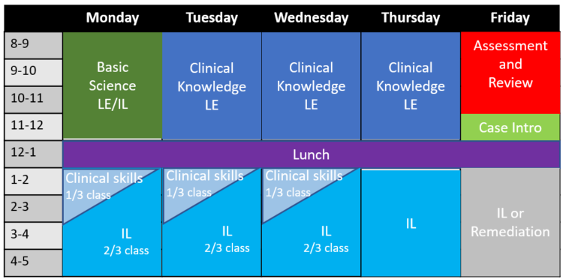

AchieveIt Update
Thursday, October 27 is the AchieveIt launch and training day. The AchieveIt platform will replace Teams and OneDrive and will allow us to communicate and submit deliverables through one outlet. As an added bonus, all participants are welcome to use AchieveIt outside of curriculum reform to help track and plan projects.
All working groups must have at least one user who takes the extended training so they can update the dashboards effectively. This person does not have to be the Lead. Please identify this person ASAP with Michelle Sergent.
Remember to RSVP for October 27 and note that in-person (with lunch) and remote options are available.
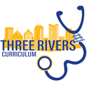
DASHBOARD
Currently under construction
We will use this area to visualize our progress.
Early Completion Percent Completion (9/15)
Longitudinal Educator Job Description
Clinical Skills Preceptor Duties and Training
Review current title/job descriptions for leadership roles
Approval of finalized Working Group membership
Due 9/23
Basic Science Educator Job Description
Due 10/15
Selection process for longitudinal educators and faculty leadership
Identify new mapping system

Countdown to March 1, 2023
128 Days
TO DO
-RSVP and attend the AchieveIt training
-If possible, bring deliverables to Steering Committee (by way of your Cluster Leads) as they are completed
-Contact your Cluster Leads with any questions
-Are their parts of our work that are publishable? Keep an eye out for opportunities within your working group to spread the word on innovations!
Under the Hood: Mandates from other Groups
Mapping and Integration WG

- Identify the new mapping system (and explore current options: Excel, Exxact, Navigator), keeping in mind requirements of the AAMC Curriculum Inventory (CI), in order to assure content integration and linkages to learning objectives and overall program objectives by October 15, 2022
- Determine the ways to train faculty on the new mapping system and students on how to use mapping to enhance learning
- Consider ways to emphasize the value of mapping course content
- Make recommendations for additional content mapping using both in-house and national themes, competencies, and keywords
- Review current objective/mapping reviews and determine appropriate review schedule
- Collaborate with the Office of Medical Education to map the curriculum as segments are built

3 Truths, One Lie about Me
Greg Null
OMED Staff,
Steering/Staff/Policy/Assessment WGs

-Holds FAA Private Pilot License
-Former brewery worker
-Sells native plants as a side gig
-Swam in Mr. Rogers’ pool

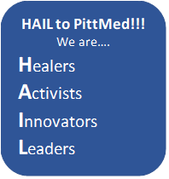
LCME and Accreditation
The Liaison Committee on Medical Education (LCME) sets forth 12 Standards made up of 93 elements that all MD-degree conferring institutions must adhere to and monitor. These individual elements include all facets of the medical school, from duration to faculty productivity to the quality of study space. The standards and elements are here.
If you have questions or concerns (or are worried that you do not have questions or concerns) on LCME elements, please reach out to Greg Null at grn18@pitt.edu. He is available for consulting with any Working Group.
UPSOM earned full accreditation for the maximum length of time in 2019. Our next reaccreditation site visit will be held in 2026-27.

