Keystone Schedule Scaffold Approved
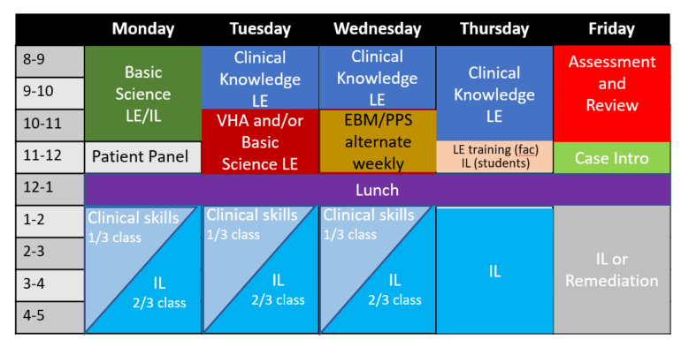
Knowledge Longitudinal Educators will teach Tuesday-Thursday mornings, with Clinical Skills Preceptors teaching revolving groups Monday-Wednesday afternoons. Evidence and Discovery and Physician, Patient, and Society content will hold a weekly slot on Wednesdays. Assessments/Review and Case Intro Fridays.
Knowledge Longitudinal Educator and Clinical Skills Preceptor Job Descriptions Approved
Patient-centered Care and the Longitudinal Educator job descriptions were approved by the Steering Committee. Longitudinal Educator is working on the selection and hiring process and is on track for approval/dissemination soon after. Stay tuned!
DASHBOARD
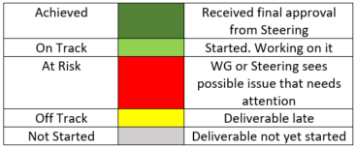
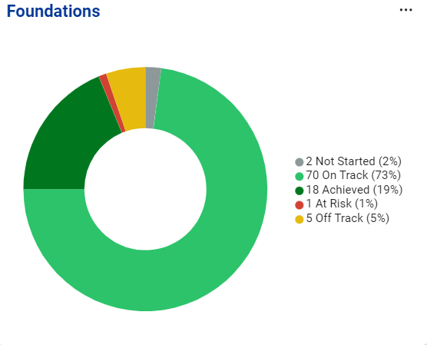
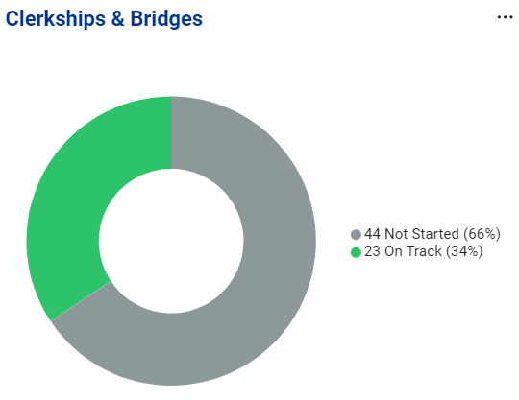
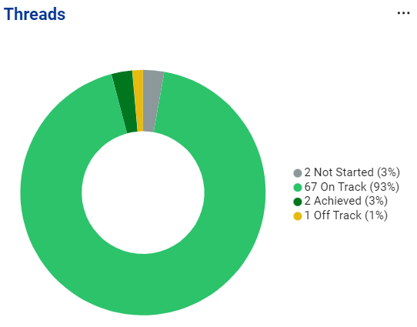
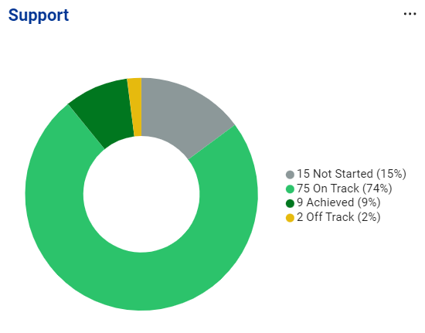
Countdown to March 1, 2023
114 Days
Under the Hood: Mandates from other Groups
Scheduling and Logistics WG

- Identify registration requirements for the University student information system, working closely with the University Registrar to guarantee compliance
- Create working models of the curriculum calendar(s), with particular attention to University scheduled time off, graduation requirements, and other events that may impact student schedules
- Decide how vacation/flex time will be scheduled in the new curriculum
- Consider how financial aid could be impacted by scheduling decisions
- Make recommendations for scheduling requirements for learners who take time off (e.g., PSTP/CSTP/MSTP students, students taking leave of absences). This includes re-entry planning and related requirements for graduation
- Collaborate with the Staff working group to make recommendations about what staff resources will be needed to support scheduling conversion to the new curriculum.
- Identify needs for registration system, working closely with iTarget to guarantee all needs can be met by the required deadline

3 Truths, One Lie about Me
Michael McDowell
Pediatric Neurosurgery, Flew Weeks Lead

-Won a steak eating contest
-Beat up on stage by William Shatner
-Barack Obama awarded him his college degree
-Completed a 5k in all 50 states

To Do
- Have you logged into AchieveIt?
- Have you set individual deadlines for your deliverables (e.g., not March 1)?
- Do you have questions on AchieveIt? Contact Katie Maietta or join a future Q&A session with the project managers from AchieveIt?

