Steering Committee Approvals
At the Nov. 22 Steering Committee, the following deliverables were approved:
- The selection process and rubric for Longitudinal Educators
- The selection process for Faculty Leadership
- The Organs System weekly scaffold (below)
- Foundation calendars for the class of 2027 and 2028
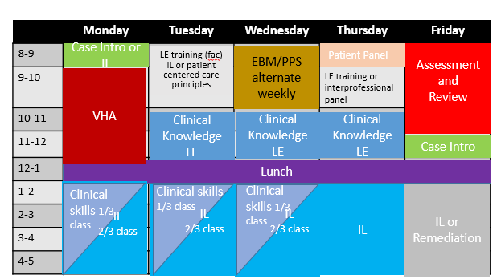
Leadership Plans Curriculum Committee Report
Leadership from the Curriculum Reform Task Force will deliver its Quarterly Report to the School of Medicine Curriculum Committee on Monday, Dec. 5.
Program Evaluation Working Group to Come Online
The Program Evaluation Working Group, whose responsibility is to track efficacy within the new curriculum, kicked off on November 28. Aaron Brown will lead the group as a subgroup with the Curriculum Committee’s Continuous Quality Improvement (CCQI) subcommittee. Students, staff, and faculty will make up group and will come from both CCQI and other parts of the school.

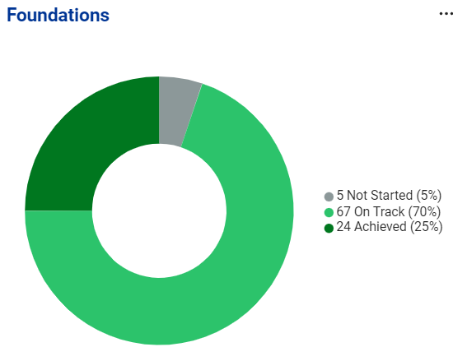
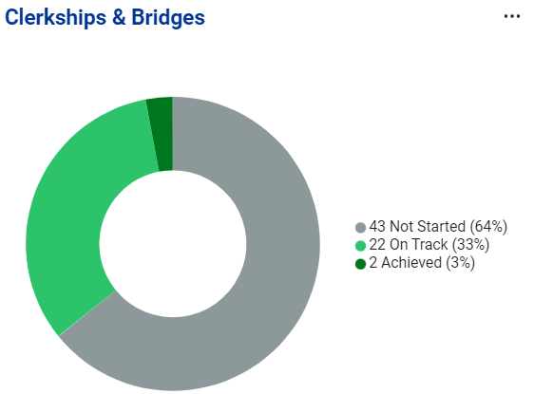
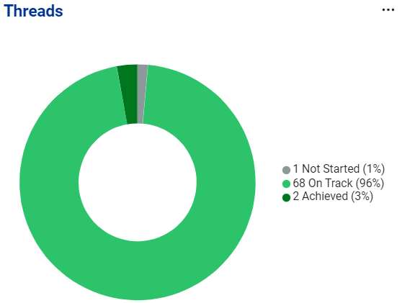
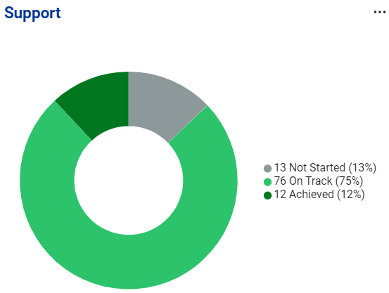

Countdown to March 1, 2023
86 Days
Under the Hood: Mandates from other Groups
Foundations Assessment
- Consider assessment needs in the foundation part of the new curriculum and recommend how those needs can be met from a resource perspective including personnel, technology and other resources:
- Work with Foundations WG to evaluate potential new assessment needs
  - Can the needs be met by adding responsibilities to current personnel
  - Current systems used in assessment at SOM include Examsoft, Navigator, CAE Learning Space and MedHub.
- Make recommendations on how assessments are constructed and utilized (who writes the questions, how is the passing threshold determined, length/duration of assessment), as well as any faculty development needs for course/thread leaders
- Set standards for assessment frequency, with specific calendar dates/times
- Explain how assessment results contribute to final grades throughout this phase of the curriculum
- Determine what kind of progress testing should be done, and the specific timing of such testing (e.g., what instrument should be used, who has access to the results)
- Make specific recommendations on how thread content will be included in Foundations assessments
- Determine basic remediation approaches, working with the Flex Weeks, Policy, and Foundations working groups (e.g., when and how students make up assessments if they initially did not meet the passing threshold, resources for students who may need additional help, when the Promotions Committee needs to be involved)
- Develop a strategy to prevent and mitigate bias in assessment

3 Truths, One Lie about Me
Arjun Mittal
MS2, Ed Tech Working Group

-Irked three different Nobel Laureates
-Completed a walking marathon
-Was once under Customs suspicion of puffin smuggling
-Followed on Twitter by a US Senator

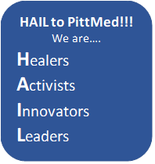
To Do
- Leads should set more exact deadlines for all deliverables (i.e. not March 1)
- Make an update in AchieveIt!

