Phase 3 Updates
The retreat got all of us off to a good start with initial meetings of the working groups. Getting a sense of the whole project of phase 3 curriculum reform, some of the early deadlines and the immediacy of the task at hand helped energize.
Many of the working groups have had their first meeting. You can find minutes and notes from them in the OneDrive site.
As working groups developed questions they sent them up the chain to the steering committee.
The steering committee had its first meeting on Tuesday 8/30. A significant time with introductions and talking through connecting Steering committee meeting members to the working groups through clusters.
Highlights of the steering committee meetings:
Delighted to have two active community members who participated and added to the discussion even at this early stage.
Working group membership is in
We did a significant amount of asynchronous work responding to working group questions through sharing documents for edits.
2 Truths, One Lie about Me
Nathalie Chen
MSTP Student, Student Co-Lead
-I worked in Dr. Fauci’s lab at the NIH
-My right lateral ventricle is larger than my left
-I used to have 6 toes on my right foot
To-Do List
- Has your group set its first meeting?
- Are you satisfied with the list of working group members (DEADLINE 9/9)?
- Contact Cluster Leads (or PM Michelle Sergent) with any issues
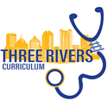
DASHBOARD
Currently under construction
We will use this area to visualize our progress.
7
Active groups with Meeting Scheduled
1 | 7 | 7
Countdown to March 1, 2023
Days

Clusters to Form
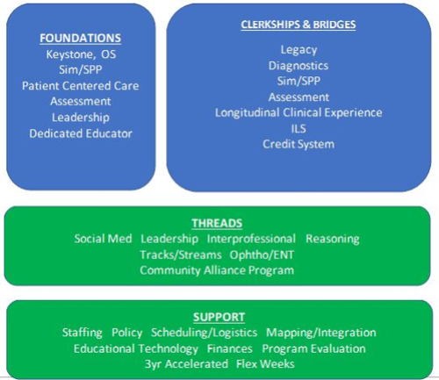

Clusters will act as the direct line to the Steering Committee and can help clarify mandates/procedures, approve new members, and help integrate the working groups within and outside of the cluster. Cluster Leads to be announced soon.

Under the Hood: Mandates from other Groups
Staffing Working Group
- Identify essential staff to support the curriculum reform.
- Collaborate with other working groups that identify the need for a new or altered staff
- position
- Consider job descriptions, expected workload, current workload and time.
- Determine if current staff positions can be rewritten and/or reclassed to meet the needs of the new curriculum
- Discuss the need for additional staff assistance and determine in which department(s) those staff should work
- Determine the timeline for onboarding new staff or adjusting the roles of current staff
- Determine the timeline to discuss changes of daily activities/roles with current staff and identify any training resources needed to support current staff
- Make recommendations for supporting staff impacted by curriculum reform increased workload.
- Collaborate with the Finance Working Group to ensure staff resources recommendations are outlined and planning can be put in place.

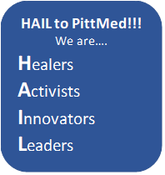
Why Main Channel?
In river morphology, a channel defines the narrow path of a body of water. The main channel is where most of the water flows and tends to be the most navigable.
One Last Thing
  - Remember to save your meeting minutes in OneDrive
    - Finalize your working group membership by Friday, Sept 9
  - Reach out with questions and concerns to your Cluster Leads/PM Michelle Sergent
    - This is a marathon not a race
      - Thank you for paving the way for the Three Rivers Curriculum

