UPSOM Tech List

Class Year 2020-2021

Required Hardware and Internet Connection (Minimum Requirements)

- (Required) One of the following devices:
A Windows PC, Surface Tablet, Mac Laptop OR iPad
PC/Surface Tablet Requirements
- Licensed Operating System: Client Versions of 32-bit and 64-bit Versions of Windows 10
- Tablet Windows OS Versions (RT and 10S) are currently unsupported
- CPU Processor: 2.0 ghz Intel i3 processor or equivalent
- RAM: 4GB or higher
- Hard Drive: highest recommended for the operating system or 1GB of available space.
- Screen Resolution should be at least 1024x768 or higher.
- Administrator level account permissions on device

Mac laptop Requirements
- Licensed Operating System: Client Versions of OS 10.13 (High Sierra), OS 10.14 (Mojave), and macOS Catalina (10.15).
- CPU: Intel 2 GHz or faster
- RAM: 4GB or higher
- Hard Drive: 1GB or higher available space
- Screen Resolution should be at least 1024x768 or higher
- Administrator level account permissions on device

iPad Tablet Requirements
- Hardware Requirements: iPad 5+, iPad Air, iPad Mini 2+, iPad Pro
- Operating System: iOS 11 or higher
- 500 MB of free space
- iPad must not be Jailbroken

- (Required) Tools for Remote Learning:

- Web camera (Integrated or USB)
- Microphone (Integrated/USB/Stereo/Bluetooth)
- 600kbps (up/down) internet connection

Recommended Hardware/Internet Connection (Recommended Requirements)

- iOS or Android Smartphone for multifactor authentication and polling using Poll Everywhere
- Peripheral mouse and keyboard for testing on Tablets through Examsoft (USB/Bluetooth)
- Noise cancelling microphone/earbuds for remote learning
- HD/dedicated web camera for remote learning
- 1.8 Mbps (up/down) internet connection

Clerkship/Shelf Exams Notice

The University of Pittsburgh School of Medicine is in the process of piloting remote testing of National Board of Medical Examiners (NBME) assessments using personal equipment. On test dates, the following equipment restrictions would apply:
NOTE: Tablets are Unsupported

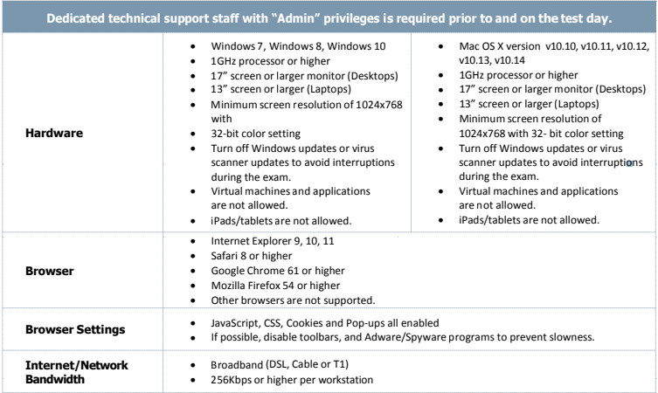

Systems and Services used in the Curriculum:
Poll Everywhere: https://www.polleverywhere.com/support
Examsoft: https://examsoft.com/pittmed
Navigator: https://navigator.pitt.edu
VPsim: https://vpsim.pitt.edu
Zoom: https://pitt.zoom.us
Microsoft Teams: https://www.technology.pitt.edu/services/microsoft-teams

Discounts for Students, Faculty, and Staff on Apple and Dell computers
https://www.pitt.edu/computer-discounts

